Images of our 2018 Christmas Celebration in Keene – 12/14-16/2018

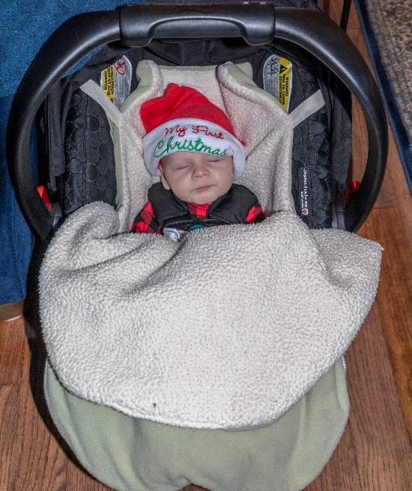

Christmas is the world-wide celebration of the birth of Jesus Christ. We are fortunate that our four families can get together during this season. This year was especially joyous as our newest grandson, Daniel Edward – 2.5 months old, joined us.

Our family members gathered at our new condo in Keene, NH, during the weekend of December 14-16. The timing does work out nicely for all our families and it was an enjoyable time for all.

And for the photos, click on [2018 Christmas](https://photos.app.goo.gl/BN5j79Ew7edmsA6KA). Feel free to “zoom”.